Alice in Wonderland, part II

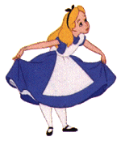
One day Alice met the Duchess who told her a rather curious thing. Some creatures in Wonderland are totally mad. They get everything wrong and one should not believe a single word of what they say. The others however always get everything right.
“That’s very interesting”, Alice said, “but who is mad and who is not?” “Well”, the Duchess said, “that, you see, I really don’t know. You have to find out!” This is what the Duchess, who is patently sane, told Alice:

- The Caterpillar thinks that both he and Bill, the Lizard are mad.
- The Cook thinks that out of her and the Cheshire Cat at least one is mad.
- The King of Hearts thinks that he and his wife are either both mad or both sane.
- The King of Diamonds says that the Queen of Diamonds thinks that she is mad.
- The Mad Hatter says that the March Hare claims that not everybody in the Mad Tea Party is sane. The Dormouse thinks that the March Hare is sane.

